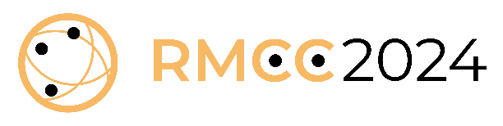
Abstract Template

Title
Please replace this text with a title with a maximum of 85 characters (including spaces).

Authors
Please replace this text with names and affiliations of all authors.
Please mark the main and corresponding author.

Abstract
Please provide an abstract with a maximum of 250 words here.

Which conference topic does the submission fit best to?
- ☐ Comparing and correlating rock mass classification systems
- ☐ Today’s rock mass classification systems in the light of sustainability, demographic change, digitalization, and open data
- ☐ Digital methods and modern technology for rock mass classification and characterization
- ☐ The future of rock mass classification – questioning the state of the art

Which publishing option would you prefer?
- ☐ A full paper in a special issue in the journal "Rock Mechanics and Rock Engineering". Authors who choose this option will get the possibility to present their work on the conference main stage.
- ☐ An open access conference paper in an "IOP Conference Series: Earth and Environmental Science" proceedings. Authors who choose this option will get the possibility to present their work through a poster in the mingling / coffee area of the conference.

Please note that the final decision about the conference topic allocation and contribution option will be made by the guest editors (Dr. Georg Erharter and Dr. Pål Jakobsen).
Personal attendance of at least one author is required for inclusion of the contribution.

Send the filled out abstract template as a pdf to: publishing.rmcc2024@ngi.no

